

## Janardhan Bhagat Shikshan Prasarak Sanstha’s

**CHANGU KANA THAKUR ARTS, COMMERCE AND SCIENCE**

## COLLEGE

**NEW PANVEL(Autonomous)**

## PROJECT ON

**Online Crime Reporting**

## DEVELOPED BY

**Mr. Prajwal .R. Mane**

## UNDER THE GUIDANCE OF

**Prof. Mrs. Ashwariya Kadam**

## ACADEMIC YEAR

### 2023-2024



**Department of Computer Science**

### CERTIFICATE

#### This is to certified that the project entitled

**“Online Crime Management”**

Is successfully completed by **Mr. Prajwal Rajesh Mane,** Roll No: 28, Examination No: **CS23634** under the guidance of **Prof. Mrs. Aishwariya Raikar**, during the academic period of 15st July 2023 to 2nd September 2023 as per the syllabus, fulfilment for the completion of the BSc degree in the Computer Science. It is also to certify that this is original work of the candidate done during academic year 2023-2024.

**Place:** Panvel

**Date:** 02/09/2023

#### Internal Examiner Principal

**External Examiner Head of Department**



# ACKNOWLEDGEMENT

It is indeed a matter of great pleasure and proud privilege to be able to present this project on “**Online Crime Reporting**.”

I would also like to express my deep regards and the gratitude towards the principal **Prof. Dr. P.D.Patil**

I respect and thank Head of the department **Prof. Mrs. Pratibha Jadhav**, for providing me an opportunity to do the project work and giving me all the support and guidance. Also, I would like to tender our sincere thank to all the teachers for their co-operation.

The completion of the project work is a milestone in student life and it execution is inevitable in the hands of guide. I am highly indebted the projects guide **Prof. Mrs. Ashwariya Kadam** for her invaluable guidance and appreciation for giving form and substance to this report. It is due to her enduring efforts; patience and enthusiasm, which has given a sense of direction and purposefulness to this project and ultimately made it a Success.

I would Wish to thank the non - teaching staff and my friends who have helped me.

Really it is highly impossible to repay the dept of all the people who have me all the time in one way or the other directly or indirectly helped me for performing the project.

# INDEX

|  |  |  |
| --- | --- | --- |
| **Sr. No.** | **Title** | **Page No.** |
| **01** | **Introduction** | **05** |
| **02** | **Requirement Specification** | **09** |
| **03** | **System Design** | **11** |
| **04** | **System Implementation** | **14** |
| **06** | **Conclusion and Future Scope** | **30** |
| **07** | **Plagiarism Report** | **32** |
| **08** | **References** | **34** |



**INTRODUCTION**



## 1.Introduction:

The Online Crime Reporting System is a cutting-edge project designed to streamline and modernize the process of reporting and tracking criminal incidents. With the ever-increasing prevalence of digital technology and internet connectivity, there is a pressing need for an efficient and user-friendly platform that enables citizens to report crimes and law enforcement agencies to manage these reports effectively. This project aims to bridge the gap between the public and law enforcement by providing a convenient and secure online platform for reporting various types of crimes, from petty thefts to more serious offenses.

The Online Crime Reporting System will empower citizens to report crimes from the comfort of their homes or using their mobile devices, thereby reducing the barriers to reporting and ensuring a timely response from law enforcement. Moreover, it will enhance the efficiency of law enforcement agencies by providing them with a centralized database of reported crimes, enabling data-driven decision-making, resource allocation, and crime trend analysis.

In this documentation, we will explore the key features and functionalities of the Online Crime Reporting System, discuss the benefits it offers to both the public and law enforcement, outline the technology stack used for its development, and provide insights into the implementation process. Additionally, we will delve into the security measures implemented to protect the integrity of the system and the privacy of users. This documentation serves as a comprehensive guide to understanding, implementing, and maintaining the Online Crime Reporting System, contributing to a safer and more connected community.

### 1.1.Existing System:

The proposed Online Crime Reporting System aims to address these limitations by providing a more streamlined, user-friendly, and technologically advanced platform for reporting crimes and enhancing the efficiency of law enforcement agencies in handling and responding to these reports.

The existing systems for online crime reporting typically vary from one jurisdiction to another, but they share several common characteristics:

1)**Traditional Phone Reporting:** Historically, people reported crimes by calling emergency numbers or non-emergency police lines. This method relies on verbal communication, making it less efficient for capturing detailed information and evidence.

2)**In-Person Reporting:** Victims or witnesses of crimes often visit local police stations to file reports in person. While this method allows for more comprehensive reporting, it can be time-consuming and inconvenient for those involved.

3)**Web-Based Forms**: Some regions have introduced web-based forms on official law enforcement websites where individuals can submit crime reports online. These forms usually require users to provide details such as the type of crime, location, date, and description.

4)**Mobile Apps:** A growing number of law enforcement agencies have developed mobile applications that enable users to report crimes using their smartphones. These apps often include features for attaching photos, videos, and additional evidence.

### 1.2.Proposed System:

Our proposed Online Crime Reporting System represents a cutting-edge solution designed to revolutionize the way crimes are reported, documented, and addressed. It leverages modern technology to create a more efficient, user-friendly, and secure platform for both the public and law enforcement agencies

**1.3.Working of system:**

1. **Login as User to Lodge a Complaint:**

As a user you can login and lodge a complaint by just login in from any where you want.

1. **Login as Admin to manage the server as Admin:**

It has a admin pannel which is used by only admin to add officers,

Add admin, and reports of the complaint.by just need to login as the admin .

1. **It has the Change password field:**

The user ads well as admin can change the password by easily clicking on the Account setting >Change password.



**REQUIREMENT SPECIFICATION**

## 2.Requirement Specification:

### 2.1.Software Requirements:

* + 1. **VScode:** version 1.82

#### Front End:

* + - 1. HTML
      2. CSS
      3. Javascript
    1. **Backend:** 1)PHP and MYSQL

2) XAMPP

### 2.2.Hardware Requirement:

* + 1. **Processor:** Intel Core i3 and above
    2. **Ram:** 4GB
    3. **Laptop with basic hardware.**



**SYSTEM DESIGN**



## 3.System Design Details:

### 3.1.Use-Case Diagram:

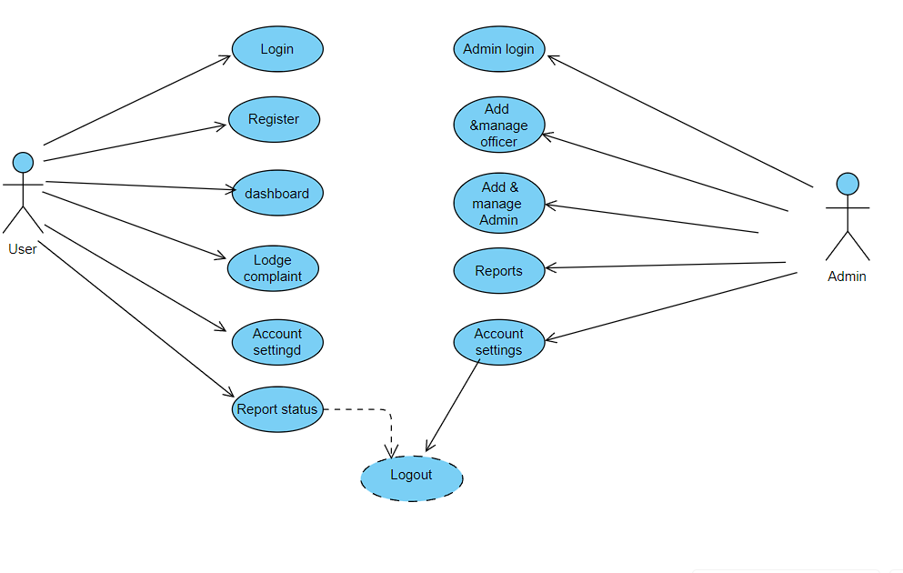

**3.2.Activity Diagram:**

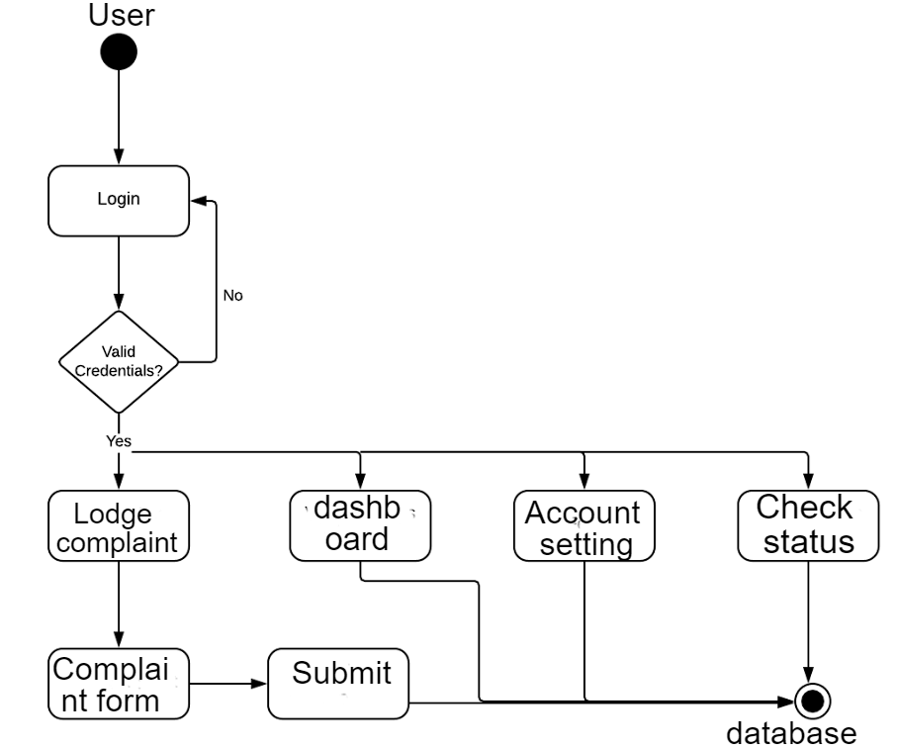

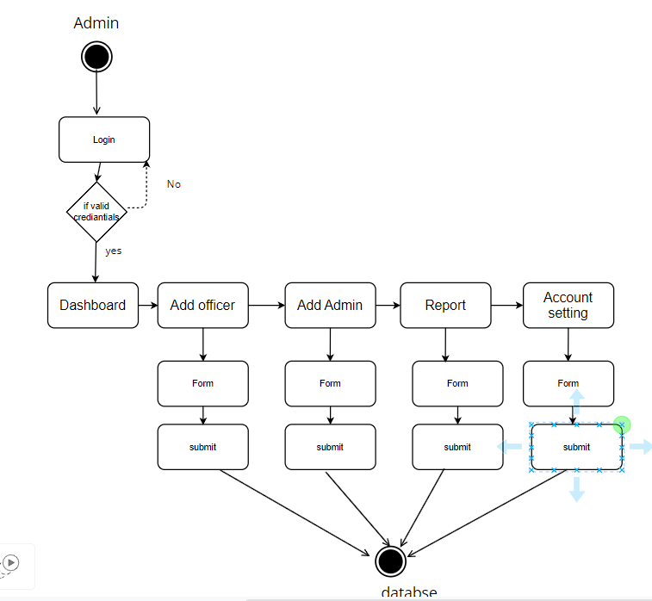

**3.3.Squence diagram:-**

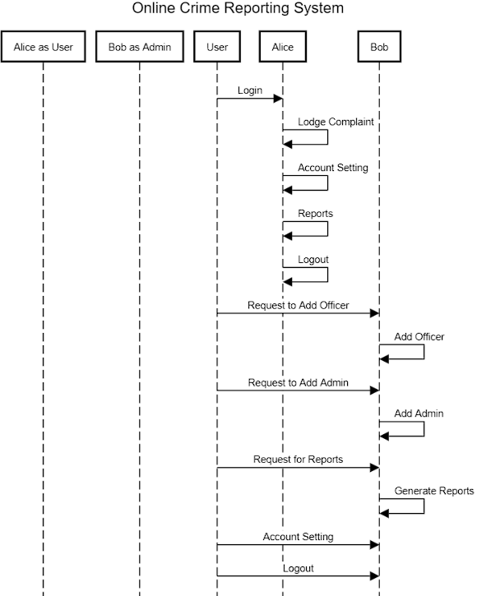



**SYSTEM IMPLEMENTATION**



## 4. System Implementation:

### User & Admin Login and register

**Login:-**

**<!DOCTYPE html>**

**<html lang="en">**

**<head>**

**<meta charset="UTF-8">**

**<meta http-equiv="X-UA-Compatible" content="IE=edge">**

**<meta name="viewport" content="width=device-width, initial-scale=1.0">**

**<link rel="stylesheet" href="https://cdnjs.cloudflare.com/ajax/libs/toastr.js/latest/toastr.min.css">**

**<link rel="stylesheet" href="login_page.css">**

**<script src="login_page.js"></script>**

**<title>login</title>**

**</head>**

**<body>**

**<header>**

**<h2 class="logo">Online Crime Reporting</h2>**

**<nav class="navigation">**

**<a href="home.html">Home</a>**

**<a href="contact.html">Contact</a>**

**<a href="About.html">About</a>**

**<button class="btnLogin-popup" id="adminLoginButton">Admin Login</button>**

**</nav>**

**</header>**

**<script>**

**function openAdminLoginPage() {**

**// Redirect to the Adminlogin.html page**

**window.location.href = "Adminlogin.html";**

**}**

**// Attach the click event handler to the button**

**document.getElementById("adminLoginButton").addEventListener("click", openAdminLoginPage);**

**</script>**

**<div class="form_box">**

**<h1>User Login</h1>**

**<form method="POST" action="login_page.php">**

**<div class="form_content">**

**<label for="email"></label>**

**<input type="text" name="email" required="required" id="email" placeholder="Email Address"></input>**

**</div>**

**<div class="form_content">**

**<label for="password"></label>**

**<div class="password-container">**

**<input type="password" name="password" required="required" id="password" placeholder="Password">**

**<span id="togglePassword" class="password-toggle" onclick="togglePasswordVisibility()">👁️</span>**

**</div>**

**</div>**

**<div class="button-panel">**

**<input type="submit" class="button" title="Sign In" value="Sign In"></input>**

**</div>**

**</form>**

**<div class="form-footer">**

**<p><a href="register.html">New here? &nbsp;<span style="color: rgb(135, 148, 235)">Create Account</span> </a></p>**

**</div>**

**<div class="down">**

**<p><a href="home.html">Go Back <i></i></a></p>**

**</div>**

**</div>**

**<footer>Copyright © crime 2023 Right Reserved.</footer>**

**<script src="//cdn.jsdelivr.net/npm/jquery@3.6.3/dist/jquery.min.js"></script>**

**<script src="https://cdnjs.cloudflare.com/ajax/libs/toastr.js/latest/toastr.min.js"></script>**

**Output:-**

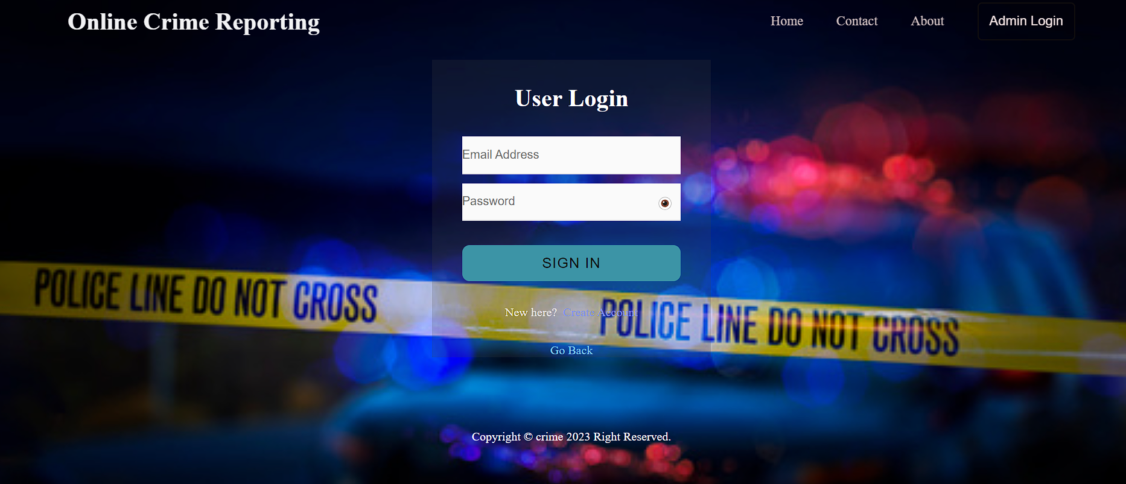

**Registration:-**

**<!DOCTYPE html>**

**<html lang="en">**

**<head>**

**<meta charset="UTF-8">**

**<meta http-equiv="X-UA-Compatible" content="IE=edge">**

**<meta name="viewport" content="width=device-width, initial-scale=1.0">**

**<link rel="stylesheet" href="login_page.css">**

**<title>Register Now</title>**

**</head>**

**<body>**

**<header>**

**<h2 class="logo">Online Crime Reporting</h2>**

**</header>**

**<div class="form_box">**

**<h1>Register Now</h1>**

**<form name="signup" action="register.php" method="post" onsubmit="validateSignup()">**

**<div class="form_content">**

**<label for="name"></label>**

**<input type="text" name="firstname" id="firstname" required="required" placeholder="Enter first name"></input>**

**</div>**

**<div class="form_content">**

**<label for="name"></label>**

**<input type="text" name="lastname" id="lastname" required="required" placeholder="Enter last name"></input>**

**</div>**

**<div class="form_content">**

**<label for="email"></label>**

**<input type="text" name="email" id="email" required="required" placeholder="Email Address"></input>**

**</div>**

**<div class="form_content">**

**<label for="number"></label>**

**<input type="text" name="number" id="number" required="required" placeholder="Phone Number"><span**

**id="numloc"></span></input>**

**</div>**

**<div class="form_content">**

**<label for="location"></label>**

**<input type="location" name="location" id="location" required="required" placeholder="Location"></input>**

**</div>**

**<div class="form_content">**

**<label for="GovNo"></label>**

**<input type="name" name="GovNo" id="document_type" required="required" placeholder="Document Type"></input>**

**</div>**

**<div class="form_content">**

**<label for="upload" class="top">Profile Picture</label>**

**<input type="file" name="upload" id="name" class="file" placeholder="Profile Picture"></input>**

**</div>**

**<!-- <div class="radio">**

**<label for="radio" class="top1">Government Id Type</label>**

**<input type="radio" name="radio" required="required" placeholder="">Passport</input>**

**<input type="radio" name="radio" required="required" placeholder="">License</input>**

**</div> -->**

**<div class="form_content">**

**<label for="upload" class="top">Government Id Photo</label>**

**<input type="file" name="upload" id="upload" class="file" placeholder="Upload Documents"></input>**

**</div>**

**<div class="form_content">**

**<label for="password"></label>**

**<div class="password-container">**

**<input type="password" name="password" required="required" id="password" placeholder="Password">**

**<span id="togglePassword" class="password-toggle" onclick="togglePasswordVisibility()">👁️</span>**

**</div>**

**</div>**

**<div class="button-panel">**

**<input type="submit" class="button" title="Sign In" value="Sign In">**

**</div>**

**</form>**

**<div class="form-footer">**

**<p><a href="login_page.html">Already have an account? &nbsp;<span style="color: rgb(135, 148, 235)">Sign In</span> </a></p>**

**</div>**

**<div class="down">**

**<p><a href="home.html">Go Back <i></i></a></p>**

**</div>**

**</div>**

**<footer>Copyright © crime 2023 Right Reserved.</footer>**

**<script src="//cdn.jsdelivr.net/npm/jquery@3.6.3/dist/jquery.min.js"></script>**

**<script src="https://cdnjs.cloudflare.com/ajax/libs/toastr.js/latest/toastr.min.js"></script>**

**<script src="register.js"></script>**

**Output:-**

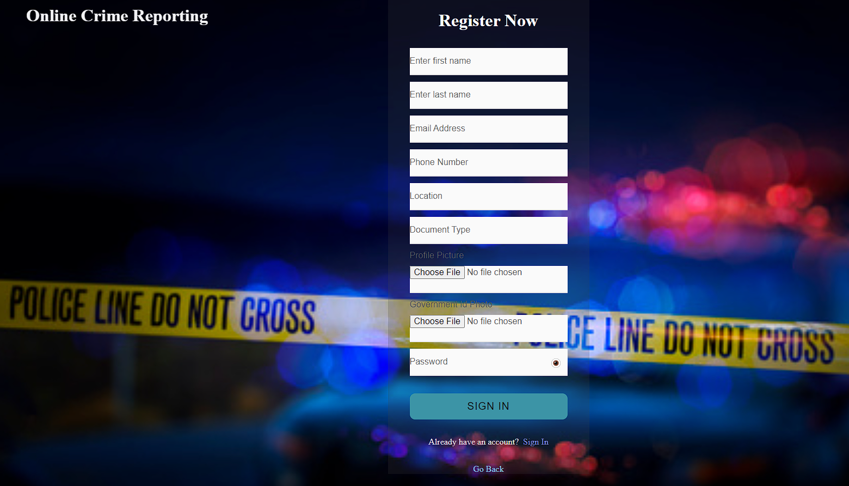

**User dashboard:-**

**<?php**

**session_start();**

**// Check if the user is logged in**

**if (!isset($_SESSION['username'])) {**

**header("Location: Login.php"); // Redirect to the login page if not logged in**

**exit();**

**}**

**?>**

**<!DOCTYPE html>**

**<!-- saved from url=(0045)http://localhost/online_crime/dashboard.html# -->**

**<html lang="en"><head><meta http-equiv="Content-Type" content="text/html; charset=UTF-8">**

**<meta http-equiv="X-UA-Compatible" content="IE=edge">**

**<meta name="viewport" content="width=device-width,intial-scale=1.0">**

**<title> Online Crime Reporting</title>**

**<link rel="stylesheet" href="style1.css">**

**<script src="https://cdn.jsdelivr.net/npm/chart.js"></script>**

**<link rel="stylesheet" href="https://cdnjs.cloudflare.com/ajax/libs/font-awesome/5.15.4/css/all.min.css">**

**</head>**

**<body>**

**<div class="sidebar">**

**<div class="logo"></div>**

**<ul class="menu">**

**<li class="active">**

**<a href="http://localhost/online_crime/dashboard.html#">**

**<i class="fas fa-tachometer-alt"></i>**

**<span>Dashboard</span>**

**</a>**

**</li>**

**<li>**

**<a href="complaint.php">**

**<i class="fas fa-file-alt"></i>**

**<span>Lodge Complaint</span>**

**</a>**

**</li>**

**<li class="dropdown">**

**<a href="changepass.php">**

**<i class="fas fa-cogs"></i>**

**<span>Account Settings</span>**

**</a>**

**</li>**

**<li>**

**<a href="Emergency.html">**

**<i class="fas fa-exclamation-triangle"></i>**

**<span>Check Status</span>**

**</a>**

**</li>**

**<li>**

**<a href="Login.php">**

**<i class="fas fa-sign-out-alt"></i>**

**<span>Logout</span>**

**</a>**

**</li>**

**</ul>**

**</div>**

**<div class="main--content">**

**<div class="header--wrapper">**

**<div class="header--title">**

**<span>Primary</span>**

**<h2>Online Crime Reporting</h2>**

**</div>**

**<div class="main--card">**

**<div class="user--info">**

**<div class="search--box">**

**<i class="fa-solid fa-search"></i>**

**<input type="text" placeholder="Search" fdprocessedid="w5hqk">**

**</div>**

**<img src="profile.jpg" alt="">**

**</div>**

**</div>**

**</div>**

**<div class="main--cards">**

**<div class="card" id="userCard">**

**<div class="card--inner">**

**<p class="text--primary">Users</p>**

**<span class="material-icon-outlined text-blue"></span>**

**</div>**

**<span class="text-primary font-weight-bold" id="userCount">0</span>**

**</div>**

**<h1 style="text-align: right;">Welcome, <?php echo $_SESSION['username']; ?>!</h1>**

**</div>**

**<div class="charts">**

**<div class="charts-card">**

**<p class="chart-title">Crime Rates</p>**

**<canvas id="bar-chart" width="500" height="357" style="display: block; box-sizing: border-box; height: 286px; width: 400px;"></canvas>**

**</div>**

**<div class="charts-card">**

**<p class="chart-title">Crimes in Maharashtra</p>**

**<canvas id="area-chart" width="500" height="357" style="display: block; box-sizing: border-box; height: 286px; width: 400px;"></canvas>**

**</div>**

**</div>**

**<script>**

**// Sample data for the bar chart**

**var barChartData = {**

**labels: ['Akola', 'Raigad', 'Navi-Mumbai', 'Mumbai', 'Pune'],**

**datasets: [{**

**label: '', // Leave the label empty here**

**backgroundColor: 'rgba(75, 192, 192, 0.2)',**

**borderColor: 'rgba(75, 192, 192, 1)',**

**borderWidth: 1,**

**data: [10, 20, 15, 25, 30]**

**}]**

**};**

**var customLabels = ['Akola', 'Raigad', 'Navi-Mumbai', 'Mumbai', 'Pune'];**

**// Sample data for the area chart**

**var areaChartData = {**

**labels: ['Jan', 'Feb', 'Mar', 'Apr', 'May', 'Jun'],**

**datasets: [{**

**label: 'Crimes in Maharashtra',**

**backgroundColor: 'rgba(255, 99, 132, 0.2)',**

**borderColor: 'rgba(255, 99, 132, 1)',**

**borderWidth: 1,**

**data: [50, 45, 60, 55, 70, 65]**

**}]**

**};**

**// Get the canvas elements**

**var barChartCanvas = document.getElementById('bar-chart').getContext('2d');**

**var areaChartCanvas = document.getElementById('area-chart').getContext('2d');**

**// Create the bar chart**

**new Chart(barChartCanvas, {**

**type: 'bar',**

**data: barChartData,**

**options: {**

**scales: {**

**y: {**

**beginAtZero: true**

**}**

**}**

**}**

**});**

**// Create the area chart**

**new Chart(areaChartCanvas, {**

**type: 'line',**

**data: areaChartData,**

**options: {**

**scales: {**

**y: {**

**beginAtZero: true**

**}**

**}**

**}**

**});**

**</script>**

**<script>**

**// Function to update the user count in the card**

**function updateUserCount(newCount) {**

**const userCountElement = document.getElementById("userCount");**

**userCountElement.textContent = newCount;**

**}**

**// Function to periodically check for updates (e.g., every 5 seconds)**

**function checkForUpdates() {**

**// Make an API request to your server to get the current user count**

**// For simplicity, we'll assume you have an API endpoint for retrieving the count.**

**// You may need to customize this part based on your server setup.**

**// For example, if you have an API endpoint like getUserCount.php**

**const updateUrl = 'https://yourwebsite.com/getUserCount.php';**

**fetch(updateUrl)**

**.then(response => response.json())**

**.then(data => {**

**// Update the user count in the card**

**updateUserCount(data.userCount);**

**})**

**.catch(error => {**

**console.error('Error fetching user count:', error);**

**});**

**}**

**// Initial check for updates**

**checkForUpdates();**

**// Periodically check for updates (every 5 seconds)**

**setInterval(checkForUpdates, 5000);**

**</script>**

**<script>**

**// Function to update the user count in the card**

**function updateUserCount(newCount) {**

**const userCountElement = document.getElementById("userCount");**

**userCountElement.textContent = newCount;**

**}**

**// Function to send an update request to get the latest user count**

**function requestUserCount() {**

**var xhr = new XMLHttpRequest();**

**xhr.onreadystatechange = function () {**

**if (xhr.readyState === 4 && xhr.status === 200) {**

**// Parse the response JSON to get the user count**

**var response = JSON.parse(xhr.responseText);**

**var userCount = response.userCount;**

**updateUserCount(userCount);**

**}**

**};**

**xhr.open('GET', 'http://localhost/crime/getUserCount.php', true);**

**xhr.send();**

**}**

**// Initial check for updates**

**requestUserCount();**

**// Periodically check for updates (e.g., every 5 seconds)**

**setInterval(requestUserCount, 5000);**

**</script>**

**</body>**

**</html>**

**<!--main end-->**

**</div>**

**<!--Scripts-->**

**<!--Apexcharts-->**

**<script src="https://cdnjs.cloudflare.com/ajax/libs/apexcharts/3.35.3/apexcharts.min.js"></script>**

**<!--Custom35-->**

**<svg id="SvgjsSvg1001" width="2" height="0" xmlns="http://www.w3.org/2000/svg" version="1.1" xmlns:xlink="http://www.w3.org/1999/xlink" xmlns:svgjs="http://svgjs.dev" style="overflow: hidden; top: -100%; left: -100%; position: absolute; opacity: 0;"><defs id="SvgjsDefs1002"></defs><polyline id="SvgjsPolyline1003" points="0,0"></polyline><path id="SvgjsPath1004" d="M0 0 "></path></svg></body></html>**

**Output:-**

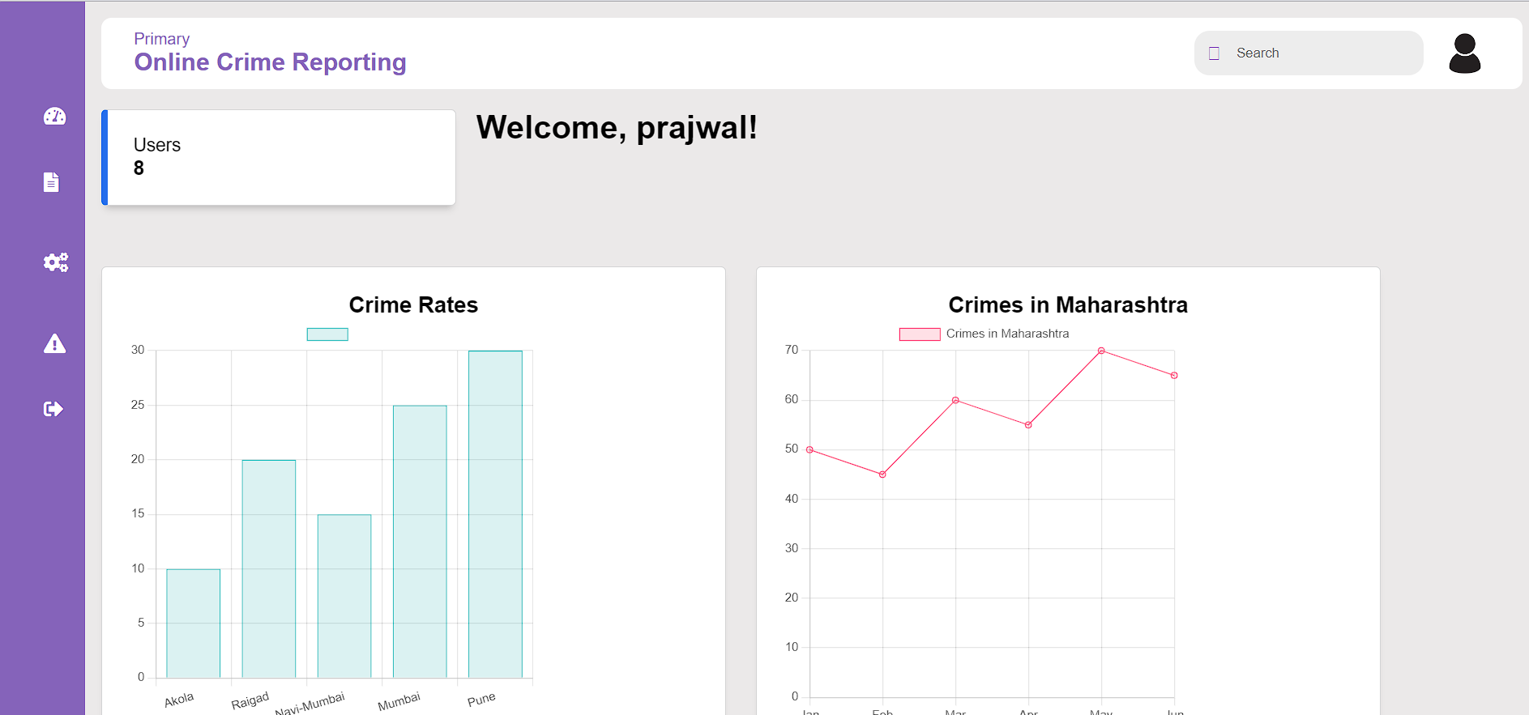

**Admin Dashboard:-**

**<?php**

**session_start();**

**// Check if the user is not logged in and redirect to the login page if necessary**

**if (!isset($_SESSION['user_id'])) {**

**header("Location: login_page.php");**

**exit();**

**}**

**// Display the welcome message with the user's first name**

**$firstname = $_SESSION['firstname'];**

**?>**

**<!DOCTYPE html>**

**<!-- saved from url=(0045)http://localhost/online_crime/dashboard.html# -->**

**<html lang="en"><head><meta http-equiv="Content-Type" content="text/html; charset=UTF-8">**

**<meta http-equiv="X-UA-Compatible" content="IE=edge">**

**<meta name="viewport" content="width=device-width,intial-scale=1.0">**

**<title> Online Crime Reporting</title>**

**<link rel="stylesheet" href="admindashboard.css">**

**<script src="https://cdn.jsdelivr.net/npm/chart.js"></script>**

**<link rel="stylesheet" href="https://cdnjs.cloudflare.com/ajax/libs/font-awesome/6.4.2/css/all.min.css">**

**</head>**

**<body>**

**<div class="sidebar">**

**<div class="logo"></div>**

**<ul class="menu">**

**<li class="active">**

**<a href="dashboard.html">**

**<i class="fas fa-tachometer-alt"></i>**

**<span>Dashboard</span>**

**</a>**

**</li>**

**<li class="dropdown">**

**<a href="h">**

**<i class="fas fa-user"></i>**

**<span>Add officer</span>**

**<i class="fas fa-chevron-down"></i>**

**</a>**

**<ul class="dropdown-content">**

**<a href="addofficer.php"><i class="fas fa-user"></i>Add Officer </a><br><br>**

**<a href="manage_officer.php"><i class="fas fa-cogs"></i>Mangage officer</a>**

**</ul>**

**</li>**

**<li class="dropdown">**

**<a href="dashboard.html#">**

**<i class="fas fa-users"></i>**

**<span>Add Admin</span>**

**<i class="fas fa-chevron-down"></i>**

**</a>**

**<ul class="dropdown-content">**

**<a href="Addadmin.php"> <i class="fas fa-users"></i>Add user</a><br><br>**

**<a href="#"><i class="fas fa-cogs"></i>Delete user</a>**

**</ul>**

**</li>**

**<li>**

**<a href="#">**

**<i class="fas fa-exclamation-triangle"></i>**

**<span>Notification</span>**

**</a>**

**</li>**

**<li>**

**<a href="storedcomplaint.php">**

**<i class="fas fa-file-prescription"></i>**

**<span>Report</span>**

**</a>**

**</li>**

**<li>**

**<a href="changepass.html">**

**<i class="fas fa-cogs"></i>**

**<span>Account settings</span>**

**</a>**

**</li>**

**<li>**

**<a href="Login.html">**

**<i class="fas fa-sign-out-alt"></i>**

**<span>Logout</span>**

**</a>**

**</li>**

**</ul>**

**</div>**

**<div class="main--content">**

**<div class="header--wrapper">**

**<div class="header--title">**

**<span>Primary</span>**

**<h2>Online Crime Reporting</h2>**

**</div>**

**<div class="main--card">**

**<div class="user--info">**

**<div class="search--box">**

**<i class="fa-solid fa-search"></i>**

**<input type="text" placeholder="Search" fdprocessedid="w5hqk">**

**</div>**

**<img src="./Online Crime Reporting_files/crime2.jpg"alt="">**

**</div>**

**</div>**

**</div>**

**<div class="main--cards">**

**<div class="card">**

**<div class="card--inner">**

**<p class="text--primary">Police Officer</p>**

**<span class="material-icon-outlined text-blue"></span>**

**</div>**

**<span class="text-primary font-weight-bold" id="officerCount">0</span>**

**</div>**

**<div class="card">**

**<div class="card--inner">**

**<p class="text--primary">Complaints</p>**

**<span class="material-icon-outlined text-blue"></span>**

**</div>**

**<span class="text-primary font-weight-bold" id="complaintCount">0</span>**

**</div>**

**<div class="card">**

**<div class="card--inner">**

**<p class="text--primary">Users</p>**

**<span class="material-icon-outlined text-blue"></span>**

**</div>**

**<span class="text-primary font-weight-bold">0</span>**

**</div>**

**<h1 style="text-align: right;">Welcome, <?php echo $firstname; ?>!</h1>**

**</div>**

**<div class="charts">**

**<div class="charts-card">**

**<p class="chart-title">Crime Rates</p>**

**<canvas id="bar-chart" width="500" height="357" style="display: block; box-sizing: border-box; height: 286px; width: 400px;"></canvas>**

**</div>**

**<div class="charts-card">**

**<p class="chart-title">Crimes in Maharashtra</p>**

**<canvas id="area-chart" width="500" height="357" style="display: block; box-sizing: border-box; height: 286px; width: 400px;"></canvas>**

**</div>**

**</div>**

**<script>**

**// Sample data for the bar chart**

**var barChartData = {**

**labels: ['Akola', 'Raigad', 'Navi-Mumbai', 'Mumbai', 'Pune'],**

**datasets: [{**

**label: '', // Leave the label empty here**

**backgroundColor: 'rgba(75, 192, 192, 0.2)',**

**borderColor: 'rgba(75, 192, 192, 1)',**

**borderWidth: 1,**

**data: [10, 20, 15, 25, 30]**

**}]**

**};**

**var customLabels = ['Akola', 'Raigad', 'Navi-Mumbai', 'Mumbai', 'Pune'];**

**// Sample data for the area chart**

**var areaChartData = {**

**labels: ['Jan', 'Feb', 'Mar', 'Apr', 'May', 'Jun'],**

**datasets: [{**

**label: 'Crimes in Maharashtra',**

**backgroundColor: 'rgba(255, 99, 132, 0.2)',**

**borderColor: 'rgba(255, 99, 132, 1)',**

**borderWidth: 1,**

**data: [50, 45, 60, 55, 70, 65]**

**}]**

**};**

**// Get the canvas elements**

**var barChartCanvas = document.getElementById('bar-chart').getContext('2d');**

**var areaChartCanvas = document.getElementById('area-chart').getContext('2d');**

**// Create the bar chart**

**new Chart(barChartCanvas, {**

**type: 'bar',**

**data: barChartData,**

**options: {**

**scales: {**

**y: {**

**beginAtZero: true**

**}**

**}**

**}**

**});**

**// Create the area chart**

**new Chart(areaChartCanvas, {**

**type: 'line',**

**data: areaChartData,**

**options: {**

**scales: {**

**y: {**

**beginAtZero: true**

**}**

**}**

**}**

**});**

**</script>**

**<script>**

**// Simulated data (you should replace this with actual data)**

**onst officerData = {**

**count: 5, // Replace with the actual count of officers**

**};**

**const complaintData = {**

**count: 10, // Replace with the actual count of complaints**

**};**

**// Function to update the officer and complaint counts**

**function updateCounts() {**

**document.getElementById('officerCount').textContent = officerData.count;**

**document.getElementById('complaintCount').textContent = complaintData.count;**

**}**

**// Call the function to update counts when the page loads**

**window.addEventListener('load', updateCounts);**

**</script>**

**<!--main end-->**

**</div>**

**<!--Scripts-->**

**<!--Apexcharts-->**

**<script src="https://cdnjs.cloudflare.com/ajax/libs/apexcharts/3.35.3/apexcharts.min.js"></script>**

**<!--Custom35-->**

**<svg id="SvgjsSvg1001" width="2" height="0" xmlns="http://www.w3.org/2000/svg" version="1.1" xmlns:xlink="http://www.w3.org/1999/xlink" xmlns:svgjs="http://svgjs.dev" style="overflow: hidden; top: -100%; left: -100%; position: absolute; opacity: 0;"><defs id="SvgjsDefs1002"></defs><polyline id="SvgjsPolyline1003" points="0,0"></polyline><path id="SvgjsPath1004" d="M0 0 "></path></svg></body></html>**

**Output:-**

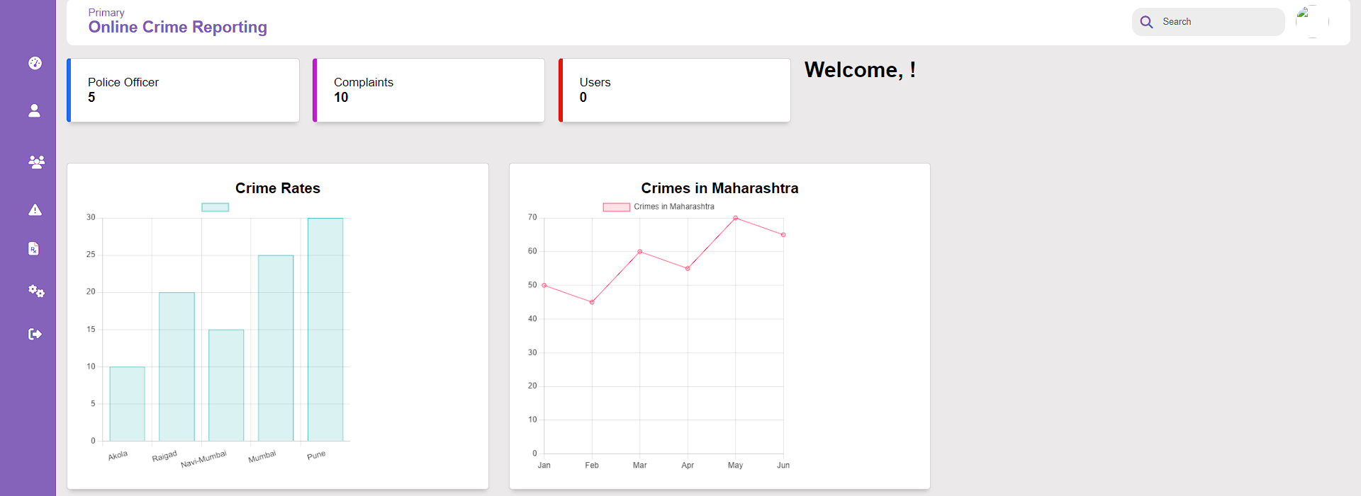



**CONCLUSION AND**

**FUTURE SCOPE**



## Conclusion and Future Scope:

**a.Conclusion:**

**1.Efficient Reporting**: It simplifies the process of reporting crimes and incidents, allowing citizens to quickly and easily communicate with law enforcement agencies.

**2.Timely Response**: The system enables law enforcement agencies to respond promptly to reported incidents, improving public safety and the overall well-being of the community.

**3.Data Analytics**: Through the collection of incident data, the system provides valuable insights to law enforcement agencies. This data can be used to identify trends, allocate resources effectively, and develop proactive strategies for crime prevention.

**4.Transparency**: It fosters transparency in law enforcement by allowing citizens to track the status of their reports and providing updates on the progress of investigations.

**5.User-Friendly Interface**: The system offers an intuitive and user-friendly interface, ensuring that citizens of all backgrounds can access and utilize its features.

### b.Future Scope:

1. **Enhanced User Experience**: Future crime reporting websites will prioritize user experience with intuitive interfaces, clear instructions, and user-friendly design. Accessibility features will be integrated to cater to all users, including those with disabilities.
2. **Mobile Optimization**: As mobile device usage continues to rise, crime reporting websites will be optimized for mobile platforms with responsive design and dedicated mobile apps, ensuring users can report incidents conveniently.
3. **Multimedia Reporting**: Users will have the ability to submit multimedia evidence such as photos, videos, or audio recordings to provide more comprehensive information about incidents.
4. **Real-Time Reporting**: The integration of real-time reporting features will enable users to report ongoing incidents as they happen, allowing law enforcement to respond quickly.
5. **Geolocation Services**: Geolocation features will enable users to pinpoint the location of incidents accurately, aiding law enforcement in dispatching resources efficiently.



**PLAGIARISM REPORT**



## Plagiarism Report:

**https://smallseotools.com/plagiarism-checker/**

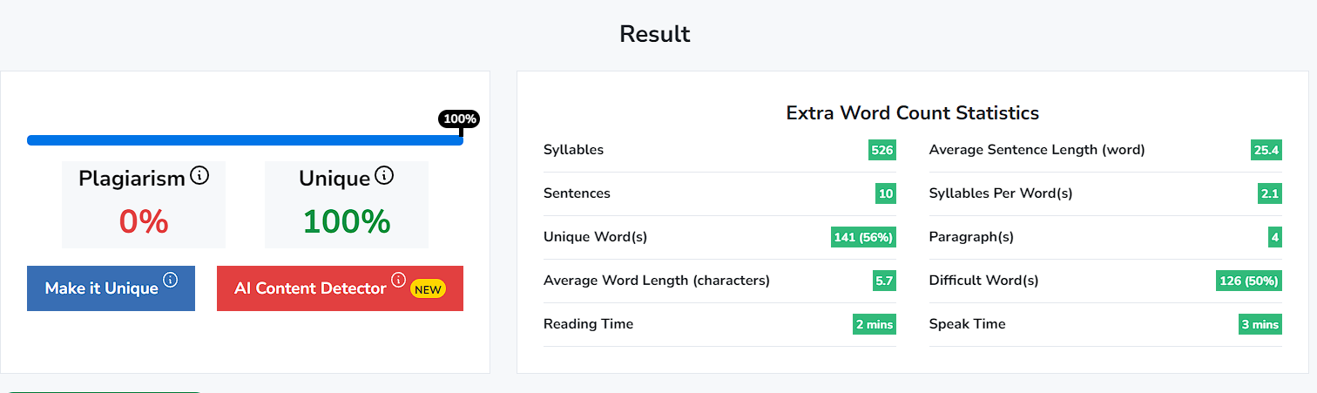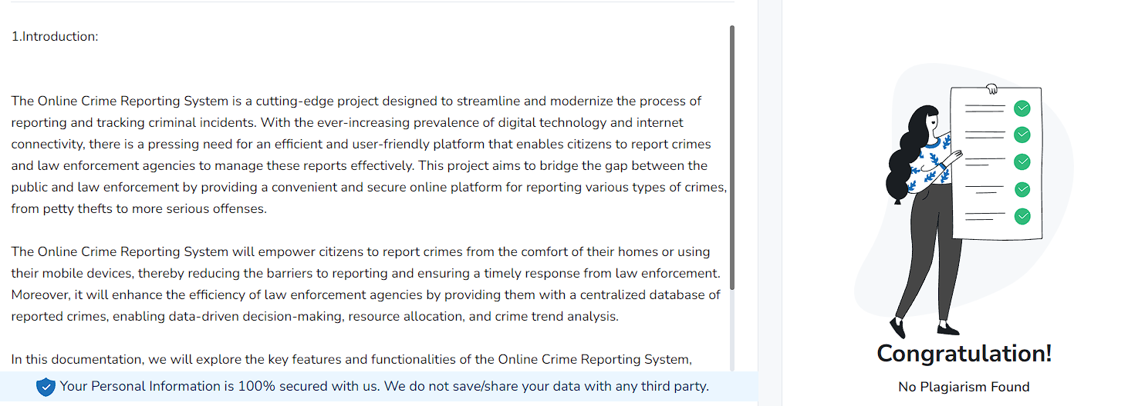



**REFERENCES**



## References:

### Books:

# Web Technologies: HTML, JAVASCRIPT, PHP, JAVA, JSP, ASP.NET, XML and Ajax, Black Book: HTML, Javascript, PHP, Java.

# MASTERING HTML, CSS & Java Script Web Publishing

### Websites:

### [www.ask.com/news/basics-website-design-html-css-explained](http://www.ask.com/news/basics-website-design-html-css-explained)

### [www.consumersearch.com/technology/html-css-building-blocks-great-website-design](http://www.consumersearch.com/technology/html-css-building-blocks-great-website-design)

### www.youtube.com